NETAJI SUBHAS INSTITUTE OF TECHNOLOGY
(University of Delhi)

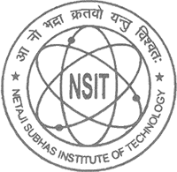

Department of Biotechnology

BACHELOR OF ENGINEERING IN BIOTECHNOLOGY
(Term Paper and Seminar Report)
FUTURE COMPUTING AND DNA HARD DRIVES
NAMAN MALHOTRA
(814/BT/14)

Supervisor: Dr. Shilpa Sharma

November 2016

Abstract
Human-beings have always been fond of accessing more and more information in minimum possible time and space. Consequently New Generation Computers and High Speed Internet have gained popularity in the recent years. We have been witness to remarkable achievements like the transition from the bulky hard-drives to the flash drives which has made personal data storage efficiently manageable.

But when it comes to handling big data, the data of a corporation or of the world as a whole, the present data storage technology comes nowhere near to be able to manage it efficiently. An urgent need for a proper medium for information archival and retrieval purposes arises. Deoxyribonucleic acid (DNA) is seen as a potential medium for such purposes, essentially because it is similar to the sequential code of 0’s and 1’s in a computer.

This field (DNA Computing) has emerged to become a topic of interest for researchers since the past decade, with major breakthroughs in its course. Seeming to come straight out of science fiction, “a penny-sized device could store the entire information as the whole Internet”.

The analyzed data from the researches reveals that just four grams of DNA can store all the information that the world produces in a year. Here, this topic of ‘FUTURE COMPUTING AND DNA HARD DRIVES’ is described starting from the very first research to the most recent one, their techniques, their advantages and their flaws, the need for DNA storage, and how it will ultimately become a paradigm shift in computing.

Acknowledgements
It is amongst the greatest clichés when writing a supervised report to say a “big thanks” to your supervisor. I really do have to express my collective gratitude towards Dr. Shilpa Sharma my project supervisor, without whose help, constant motivation and support throughout, this term-paper would not have been possible.
Secondly I would like to thank Dr. Yatender Kumar for his time, which helped me better understanding of the scientific terms and processes.
Dr. Faruq, of the Institute of Genomics and Integrative Biology (IGIB), for motivation and understanding of fundamental concepts of Genomic Coding and Data Storage.

TABLE OF CONTENTS
CONTENTS PAGE
1 Topic Motivation 5
2 Description 6
2.1 Research Paper 6
2.2 Introduction 6
2.3 Why we need alternative form of Data storage 7
3 DNA as data storage 8
3.1 What is a DNA? 8
3.2 Why replace DNA with conventional data storage devices 8
3.3 Previous DNA-based Storage approaches 9
3.4 Problem with previous methods 9
4 Encoding – Decoding 10
4.1 Encoding Device (Oligonucleotide synthesis) 10
4.2 Data Encoded 10
4.3 Encoding Process 11
4.4 Decoding Device 11
4.5 Decoding Process 12
5. Advantages and Challenges 12
5.1 Advantages 12
5.2 Challenges 13
6. Result and Conclusion 14
6.1 The Result 14
6.2 The Conclusion 14
6.3 Future Work 15
7. References 15
7.1 Research Papers 15
7.2 Internet References 15

1 Topic Motivation
As a student of biotechnology, my interest always inclined towards the field of bioinformatics. I am fascinated by the power it has, and things which can be done with proper handling of biological data. For me it’s the technology of the future and not more than 10 years from now; we will see a drastic progress in the field of bioinformatics and bio data analysis.
I am technology geek as well, whenever I buy a new phone or laptop it gets slow within few months. Due to the amount of data generated and apps installed. Then I had to install a number of data optimizing apps to clean the space.
One day when I was reading about the marvelous structure of DNA, and information it stores. I thought, why this can’t be used to store our digital information that we have on our personal computers, laptops, mobiles etc. DNA is literally the programming language for living organism.
I began to explore, more about this technology and what progress others have made so far in storing digital data steam in DNA.

2 Description

2.1 Research Paper

Towards practical, high-capacity, low-maintenance information storage in synthesized DNA.
Authors: Nick Goldman et al.
Nature 494, 77–80 (07 February 2013) doi:10.1038/nature11875 Received 15 May 2012; Accepted 12 December 2012; Published online 23 January 2013

2.2 Introduction
Digital production, transmission and storage have revolutionized how we access and use information but have also made archiving an increasingly complex task that requires active, continuing maintenance of digital media. This challenge has focused some interest on DNA as an attractive target for information storage because of its capacity for high-density information encoding, longevity under easily achieved conditions and proven track record as an information bearer.
Here we describe a scalable method that can reliably store more information than has been handled before. We encoded computer files totaling 739 kilobytes of hard-disk storage and with an estimated information 10 of 23106 bits into a DNA code, synthesized this DNA, sequenced it and reconstructed the original files with 100% accuracy. Theoretical analysis indicates that our DNA-based storage scheme could be scaled far beyond current global information volumes and offers a realistic technology for large-scale, long-term and infrequently accessed digital archiving.

2.3 Why we need alternative form of Data storage

According to a research by science daily, 90 percent of the all the data in the world has been generated over the last two years.

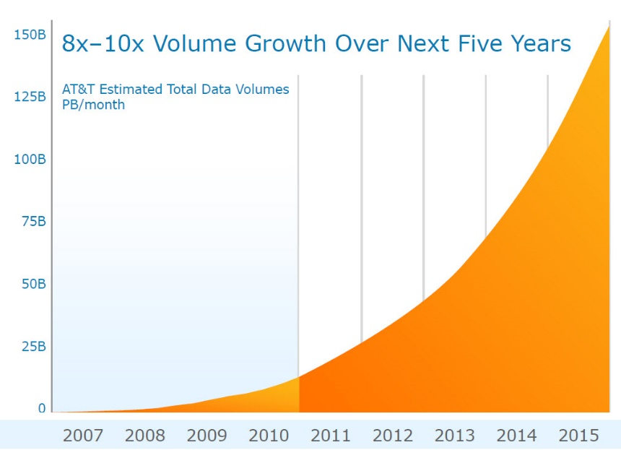

3 DNA as data storage
Before Jumping onto the procedure and devices used, we must understand the basics of DNA.

What is a DNA?
DNA, or deoxyribonucleic acid, is the hereditary material in humans and almost all other organisms. Nearly every cell in a person’s body has the same DNA. Most DNA is located in the cell nucleus, but a small amount of DNA can also be found in the mitochondria as well.
The information in DNA is stored as a code made up of four chemical bases: adenine (A), guanine (G), cytosine (C), and thymine (T). Human DNA consists of about 3 billion bases, and more than 99 percent of those bases are the same in all people. The order, or sequence, of these bases determines the information available for building and maintaining an organism, similar to the way in which letters of the alphabet appear in a certain order to form words and sentences.

3.2 Why replace DNA with conventional data storage devices

- Capacity for high-density – 1 Gram of DNA can store 455 Exabyte
  - 1 Gm DNA = 455 EB
  - 1 EB = 10^9 GB

- Durability –
  - 45,000-year-old leg bone from Siberia.
  - 430,000-year-old DNA of Neanderthals.
  - 700,000-Year-Old Horse DNA.

- Great Information Bearer – DNA is heredity material for almost all of the organism. Nearly every cell in a person’s body has the same DNA. An important property of DNA is that it can replicate, or make copies of itself. Each strand of DNA in the double helix can serve as a pattern for duplicating the sequence of bases.

Previous DNA-based Storage approaches
- Craig Venter Institute. (Maryland, US)

  - In 2010 they were able to encode a 7920-bit watermark in the genome of bacteria.

  - First project to encode a larger amount of information into DNA.

- Church et al

  - First converted 11 JPG images, an html coded draft of an approximately 53,000 words book (“Regenesis”- by Church, and a JavaScript program into a 5.27 megabit bit stream (set of binary 0’s and 1’s).

  - Assigned 0 as A or C (Adenine and Cytosine) and 1 as T or G

Problem with previous methods

- Trivial amounts of information.

  - Only a limited amount of information could be stored in DNA during early attempts.

- Not easily scalable.

  - Methods practiced during early stages were not scalable to store large amounts of data.

- No robust error-correction

  - Early methods adopted my Maryland institute and Church et al, didn’t have a fail-safe mechanism in place.

Encoding – Decoding
At first, the files that needs to be encoded in DNA has to be converted into the form of ATGC sequence. For that first the file is converted into binary then encoded into base 3 Huffman compression, i.e. data is compressed. Then finally encoded into DNA format.

4.1 Encoding Device (Oligonucleotide synthesis)
In order to store the custom data into DNA, it has to be synthesized artificially using Oligonucleotide synthesis.
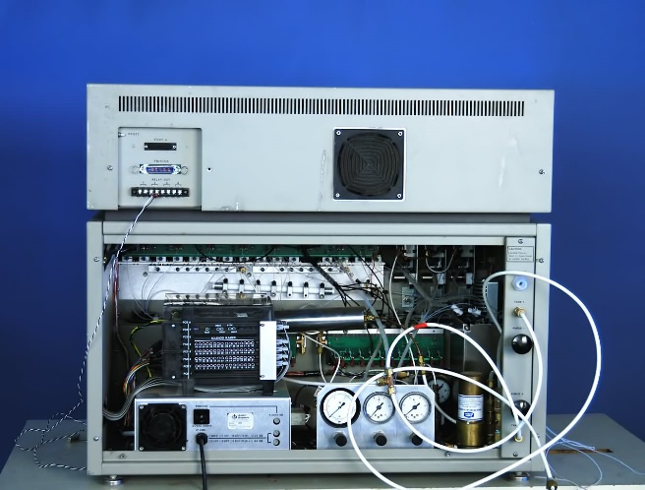

4.2 Data Encoded

Nick Goldman and his group wanted this experiment to be as realistic as possible. So the stored the real life data stored in their hard drives into DNA.
Five files: 757,051 bytes total:-

- All 154 of Shakespeare's sonnets (ASCII)
- Classic scientific paper (PDF)
- Medium resolution color photo (JPEG)
- 26-s excerpt from Martin Luther King's 1963 'I have a dream' speech (MP3)
- Huffman code used to convert bytes to base-3 digits (ASCII)

4.3 Encoding Process
Data once written into DNA, has to be converted back into the digital form to be of use. 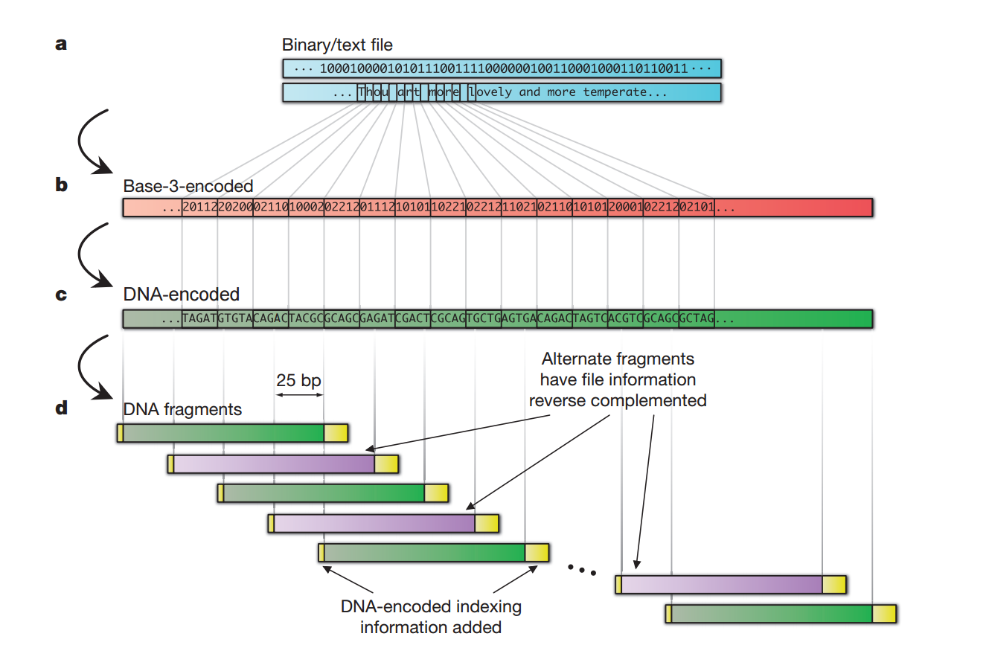

4.4 Decoding Device

MinION developed by Oxford NANOPORE Technologies.
MinION is a portable sequencer which can sequence data from DNA, RNA, proteins.
The portable MinION device works with consumable flow cells that contain the proprietary nanopore sensing apparatus required to perform experiments.
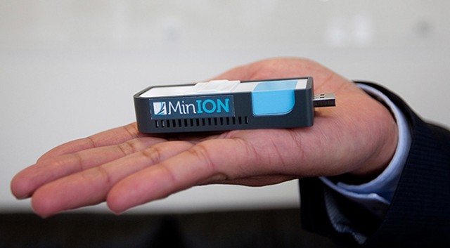
It costs around $1000 and requires 6 hours to sequence the Genome.

4.5 Decoding Process

- Full length (117 nt) DNA strings reconstructed in silico.
- Discarded the redundant strings.
- The DNA sequences representing all of the files were then reconstructed using sophisticated computer software.

5. Advantages and Challenges

5.1 Advantages
Storing DATA into DNA comes with many advantages.
- Compact Size, huge data.

  - As we have discussed, that whole data that is currently present in the world can be stored in the back of a SUV, if stored using DNA.

- Easy to copy.

  - DNA is very easy to copy by using various process such as PCR.

- Longevity / Durability.

  - DNA can store information for millions of years under right conditions.

5.2 Challenges

Whenever there is a breakthrough in technology there are several challenges to overcome.
- Difficulty in synthesizing long sequences of DNA.

  - DNA is a fragile molecule, if length of DNA produced is too long. Then there is chance of breakage and loss of information.

- Cost of Writing the data into DNA is $11,000 / MB

  - High cost is due to lack of technological advances in DNA manipulation.

- Absence of error correction enzymes.
  - Currently solved by introducing redundancy.

6. Result and Conclusion

6.1 The Result

- 4 out of 5 files were fully decoded without intervention.
- Fifth contained 2 gaps, 25 bases each.
- Inspection of neighboring regions allowed to hypothesize missing fragments.
- After manually inserting 50 bases, the original file had been reconstructed with 100% accuracy.
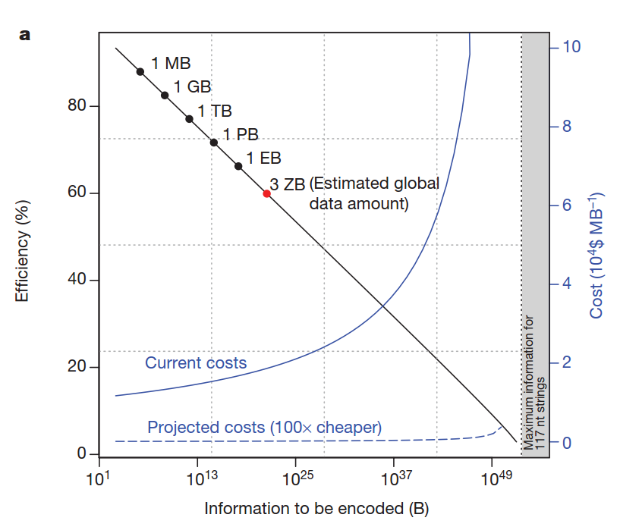

6.2 The Conclusion

It is clear that data storage in DNA is no more confined to science fiction but is being realized and improvised at very promising rates by research teams all over the world. This idea has received positive criticism from the general public as can be inferred from their responses on the different science websites.
Similar to all revolutions in technology, DNA-based data storage technology has to face major challenges to realize its full potential. It is however, inevitable that DNA would be invariably used for archival purposes for its sheer density, robustness, stability and energy efficiency. In theory, grams of DNA can store all the information ever produced by mankind. Several breakthroughs will be required before it becomes commercially mainstream for data retrieval.

6.3 Future Work

Future work could include compression schemes dealing with redundancy at all levels, checking for parity correcting errors to enhance density and safety. DNA could also be substituted with polymers or be modified to suit the needs of digital storage. Furthermore, it will fuel research to look for alternative materials for information storage and to aid in realizing the need for a universal medium for data. Overall, this technology is here to stay and could transform the way we have ever looked at DNA and computing as totally different entities.
Bibliography

7. References

7.1 Research Papers

[1] N. Goldman, P. Bertone, S. Chen, C. Dessimoz, E. M. Le Proust, B. Sipos, and E. Birney, “Towards practical, high-capacity, lowmaintenance information storage in synthesized DNA,” Nature, vol. 494, no. 7435, pp. 77-80, 2013.
[2] C. T. Clelland, et al., “Hiding messages in DNA microdots,” Nature, vol. 399, no. 1033, pp. 533–534, 1999.
[3] C. Bancroft, T. Bowler, B. Bloom, and C. T. Clelland, “Longterm storage of information in DNA,” Science, vol. 293, no. 5536, pp. 1763-1765, 2001.
[4] Church, G.M. et al. 2012. Next-generation digital information storage in DNA. Science. 337, 6102 (2012), 1628.
[5] Sony 2014. Sony develops magnetic tape technology with the world’s highest recording density. http://www.sony.net/SonyInfo/News/Press/201404/14-044E/

7.2 Internet References
https://nanoporetech.com/products/minion- minION
http://www.unitconversion.org/numbers/binary-to-base-3-conversion.html - Bin to Base 3
https://www.youtube.com/watch?v=tBvd7OSDGgQ – Video on DNA data storage by Nick Goldman.
http://homes.cs.washington.edu/~bornholt/dnastorage-asplos16/

